Meta Title
Somnath Temple Darshan Timings, History & Temple Information

Meta Description
Explore Somnath Temple darshan timings, history, aarti & travel info. Plan your visit and experience divine blessings of Lord Shiva.
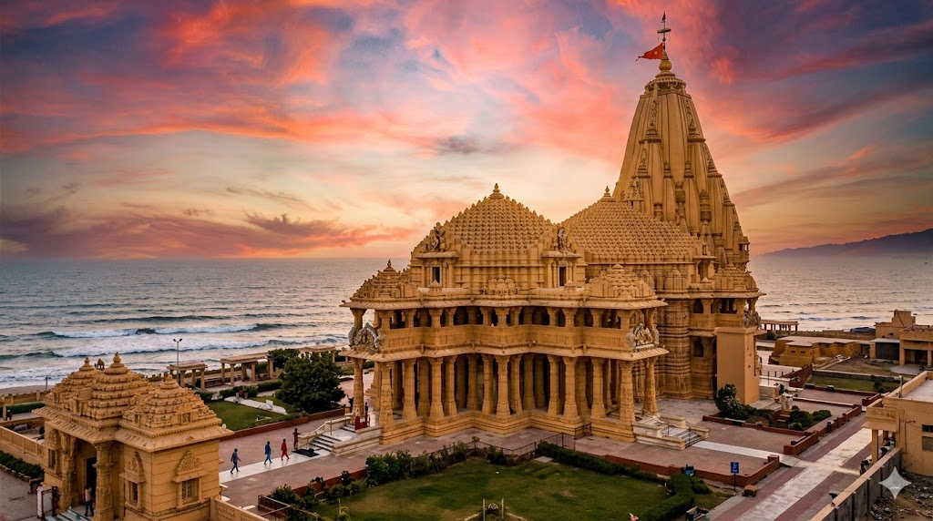
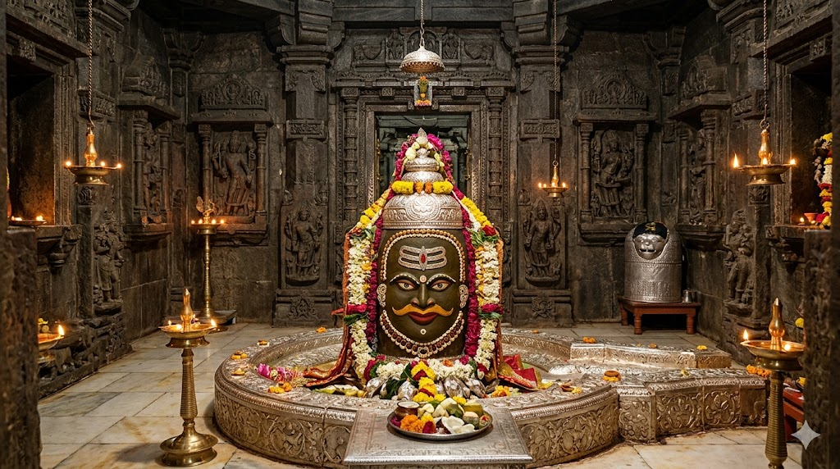

Somnath Temple – Darshan Timings, History & Temple Information
Experience the divine presence of Lord Shiva at the sacred Somnath Temple, one of the most revered pilgrimage sites in India and the first Jyotirlinga among the twelve Jyotirlingas.
This is not just a temple—it is a powerful symbol of faith, resilience, and eternal spiritual energy.
Plan your Somnath Temple darshan with proper understanding and avoid unnecessary hassle during your visit.
✔ Darshan Planning Support Available
✔ Pooja & Abhishek Arrangements
✔ Trusted Assistance for Devotees Across India
Faster Darshan Assistance
Limited Slots Available During Peak Days – Plan in Advance

Somnath Temple – Quick Info
- Location: Prabhas Patan, Gujarat
- Temple: Somnath Jyotirlinga
- Deity: Lord Shiva
- Significance: First Jyotirlinga
- Darshan Timings: Morning to Night
- Best Time to Visit: October to March
- Peak Time: Mahashivratri, Shravan Month, Weekends

The Story of Somnath Temple – The Eternal Jyotirlinga of Lord Shiva
The story of Somnath Temple is not just a historical account—it is a timeless reflection of devotion, destruction, and divine resurrection.
According to ancient Hindu scriptures, the temple was originally established by Chandra Dev (the Moon God). It is believed that Chandra was cursed by Daksha Prajapati, which led to the loss of his radiance and strength. In search of relief, he performed intense penance and worshipped Lord Shiva at this sacred site.
Moved by his devotion, Lord Shiva freed him from the curse and manifested here as the Somnath Jyotirlinga, giving the temple its name—Somnath, meaning “Lord of the Moon.”
What makes Somnath Temple truly extraordinary is its history of repeated destruction and rebuilding.
Over centuries, the temple faced multiple invasions, most notably by Mahmud of Ghazni, who destroyed the structure and looted its wealth. Yet, each time the temple was destroyed, it was rebuilt with even greater devotion and determination.
This continuous cycle represents:
- The indestructible nature of faith
- The eternal presence of Lord Shiva
- The spiritual strength of Sanatan Dharma
The present structure, rebuilt in 1951, stands majestically on the shores of the Arabian Sea, symbolizing faith that no force can destroy.
When devotees visit Somnath Temple, they are not just visiting a sacred place—they are experiencing a living legacy of devotion that has stood the test of time.

Spiritual Significance of Somnath Temple
Devotees believe that:
- Somnath is the first and most powerful Jyotirlinga
- Darshan here helps remove negative energies
- Worship brings peace, health, and prosperity
- It represents the cycle of creation, destruction, and rebirth
This is why Somnath Temple darshan holds such deep spiritual value.

Somnath Temple Darshan Timings & Aarti Schedule
Ritual / Darshan | Timing | Notes
Morning Darshan | 6:00 AM – 12:00 PM | Open for devotees
Temple Break | 12:00 PM – 3:00 PM | Closed
Evening Darshan | 3:00 PM – 10:00 PM | Open
Morning Aarti | 7:00 AM | Daily
Noon Aarti | 12:00 PM | Daily
Evening Aarti | 7:00 PM | Daily
Best Time for Darshan: Early morning or after evening aarti for a more peaceful experience

Festivals & Best Time to Visit
Somnath Temple comes alive during:
- Mahashivratri – Grand celebrations and night-long worship
- Shravan Month – Special significance for Lord Shiva devotees

Best Time to Visit:
- October to March (pleasant weather)
- Weekdays for relatively less crowd

How to Reach Somnath Temple
- By Air: Nearest airport is Diu (approx. 85 km)
- By Train: Veraval Railway Station (approx. 7 km)
- By Road: Easily accessible via Gujarat highways

Hotels & Nearby Places

Stay Options:
- Budget dharamshalas
- Mid-range hotels
- Premium accommodations

Nearby Places:
- Triveni Sangam
- Bhalka Tirth
- Gir National Park

Plan Your Darshan
Planning your visit to Somnath Temple?
You can arrange:
- Darshan as per your schedule
- Pooja & Abhishek participation
- Prasad & offerings
- Travel & stay

Info & FAQs – Somnath Temple

Where is Somnath Temple located?
Somnath Temple is located in Prabhas Patan near Veraval in Gujarat, along the Arabian Sea coast.

Why is Somnath Temple famous?
It is the first Jyotirlinga of Lord Shiva and symbolizes eternal faith, power, and spiritual strength.

What is the history of Somnath Temple?
The temple was originally established by Chandra Dev and has been rebuilt multiple times after invasions, representing the resilience of devotion.

What are the darshan timings of Somnath Temple?
Morning: 6:00 AM to 12:00 PM
Evening: 3:00 PM to 10:00 PM

What is the best time to visit Somnath Temple?
October to March and early morning or evening for a peaceful darshan.

How much time does darshan take at Somnath Temple?
General darshan can take around 1 to 3 hours depending on crowd.

Is Somnath Temple a Jyotirlinga?
Yes, it is the first among the 12 Jyotirlingas of Lord Shiva.

What is the dress code for Somnath Temple?
Devotees are advised to wear modest and traditional attire.

Are mobile phones allowed inside the temple?
Mobile phones are generally restricted inside the temple premises.

Are there accommodation options near Somnath Temple?
Yes, there are dharamshalas, hotels, and premium stays available nearby.

What are the nearby places to visit?
Triveni Sangam, Bhalka Tirth, and Gir National Park.

How can I reach Somnath Temple?
By air (Diu), train (Veraval), or road connectivity.

Is online darshan available?
Yes, online darshan options may be available for devotees who cannot visit physically.

Can I plan darshan or pooja in advance?
Yes, darshan, pooja, and temple arrangements can be planned in advance to avoid inconvenience.

What makes Somnath Temple spiritually important?
Somnath represents the eternal presence of Lord Shiva and the victory of faith over destruction. Visiting the temple is believed to bring peace, strength, and spiritual upliftment.

